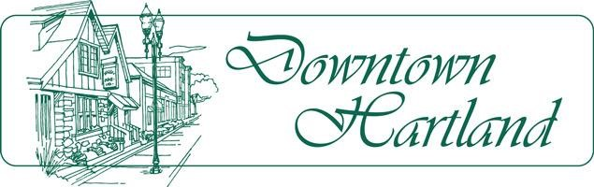

Meeting Agenda
Hartland Business Improvement District

BID Marketing Committee Meeting – Friday, March 4, 2016, 8:30 AM
Location: BID Office, 135 Cottonwood Ave, Hartland WI

Marketing Committee members: Scott Heyerdahl, Marlene Millevolte, Sarah Fitch, Dr. Jim Muenzenberger, Bill Anderson, Elise Miller, Steve Berger, Cindy Gardner

Agenda

- Feedback from Poker Pub Walk Feb. 25
- Lake Country Mom advertising option
- BID Spring Social April 20
- 9am – Ana Alarcon & Elise Miller, Hartland’s Neighborhood Night Out, to discuss evening’s events on Aug. 4. IAT county chapter invited to attend.

___________________________________________________________________________________

BID Design Committee Meeting - Friday, March 4, 2016, 10:00 AM
Location: BID Office, 135 Cottonwood Ave, Hartland WI

BID Design Committee members: Mike Badani, Dr. Jim Muenzenberger, Cindy Gardner, Tom Brass

Agenda

Sign grant application – James Mattox for 103 North Ave., Shoreline Cycle World

Agenda subject to change without notice.

