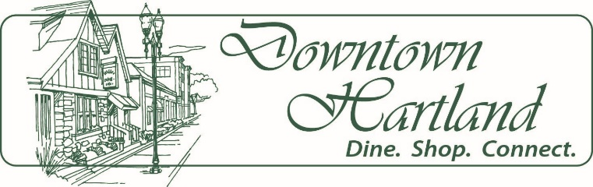
Meeting Agenda
Hartland Business Improvement District
Board of Director’s Meeting
Tuesday, August 11, 2020, 7:30 a.m.
Village of Hartland Board Room, 210 Cottonwood Ave. lower level, Hartland, WI

- Call to Order - BID President

- Approval of Meeting Minutes – June 16, 2020

- Approval of Meeting Minutes – July 24, 2020

- President’s Report - BID President
- Introduction of new BID Executive Director
- Introduction of BID Board
- Financial Report - BID Treasurer
a) Statements of operation and balance sheets June - July

- Committee Reports
- Marketing Committee – No July meeting
Aug 7 Meeting comments.
- Design Committee – No July meeting.
Aug 7 Meeting RE: Pat Walker and Mark Klink grant loan applications.
Aug 7 Meeting RE: Sign request from Grandma’s House

- Economic Development Committee – July 15th Meeting, chairman comments
- Executive Committee

- BID Director Report – Update on district business activity

- State of the Village – Village Administrator

- Adjourn

Next Meeting: Next meeting tentatively scheduled for September 8, 2020, at 7:30 a.m.

Hartland BID Mission Statement
The mission of the Hartland BID is to provide leadership for the vitality of downtown Hartland; an area that offers a variety of commercial, retail and service businesses. The BID serves as a catalyst to improve and promote downtown Hartland through business development, marketing, economic development and business education.
Goal: The Business Improvement District attracts people to live, work, shop, conduct personal business and seek entertainment in downtown Hartland.

